**EXPERIMENT – 2.2**

**Name: Ravi Shankar Singh UID: 21BCS11619**

**Branch: CSE Section/Group: 808-B**

**Semester: 4th Date of Performance:**

**Subject Name: Programming in Python lab Subject Code: 21CSP-259**

**Aim:**

1. Write a Python program to get a list, sorted in increasing order by the last element in each tuple from a given list of non-empty tuples
2. Write a Python program to print a specified list after removing the 0th, 4th and 5th elements, Sample List : ['Red', 'Green', 'White', 'Black', 'Pink', 'Yellow'],Expected Output : ['Green', 'White', 'Black']

**Source code:**

1. **Write a Python program to print a specified list after removing the 0th, 4th and 5th elements, Sample List : ['Red', 'Green', 'White', 'Black', 'Pink', 'Yellow'],Expected Output : ['Green', 'White', 'Black']**

list1 = ['Red', 'Green', 'White', 'Black', 'Pink', 'Yellow']

del list1[5]

del list1[4]

del list1[0]

print(list1)

**Output:**

**Source code:**

1. **Python program to check whether the string is Symmetrical or Palindrome.**

stri = input("Enter the Word: ")

length = len(stri)

j = length-1

temp = 0

for i in range(length):

if(stri[i] == stri[j]):

j = j-1

continue

else:

temp = -1

print(stri+" is not Symmetrical or Palindrome")

break

if(temp == 0):

print(stri+' is Symmetrical or Palindrome')

**Output:**

**Source code:**

1. **Python program to find uncommon words from two Strings**

string1 = input("Enter the first word: ")

string2 = input("Enter the second word: ")

def word(string1,string2):

word1 = string1.split()

word2 = string2.split()

x= set(word1)

y= set(word2)

uncoman_word = x.symmetric_difference(y)

return uncoman_word

res = word(string1, string2)

print(res)

**Output:**

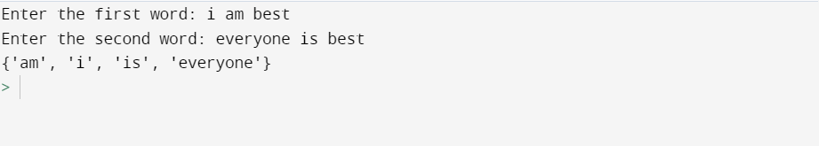

**Source code:**

1. **Write a Python program to add ‘ing’ at the end of a given string (length should be at least 3). If the given string already ends with ‘ing’ then add ‘ly’ instead. If the string length of the given string is less than 3, leave it unchanged. Example:- Sample String : ‘abc’ Expected Result : ‘abcing’ Sample String : ‘string’ Expected Result : ‘stringly’**

string = input("Enter the string: ")

length = len(string)

if(length>=3):

if(string[length-1] == "g" and string[length-2]== "n" and string[length-3]=="i"):

print(string+"ly")

else:

print(string+"ing")

else:

print(string)

**Output:**

